--*********************************************************************************--

-- Day 5 --

--*********************************************************************************--

/*1. GROUP BY with WHERE - Orders by Year and Quarter

Display, order year, quarter, order count, avg freight cost only for those orders where freight cost > 100*/

SELECT

EXTRACT(YEAR FROM order_date) AS order_year,

EXTRACT(QUARTER FROM order_date) AS order_quarter,

COUNT(*) AS order_count,

AVG(freight) AS avg_freight

FROM orders WHERE freight > 100

GROUP BY EXTRACT(YEAR FROM order_date), EXTRACT(QUARTER FROM order_date)

ORDER BY order_year, order_quarter;

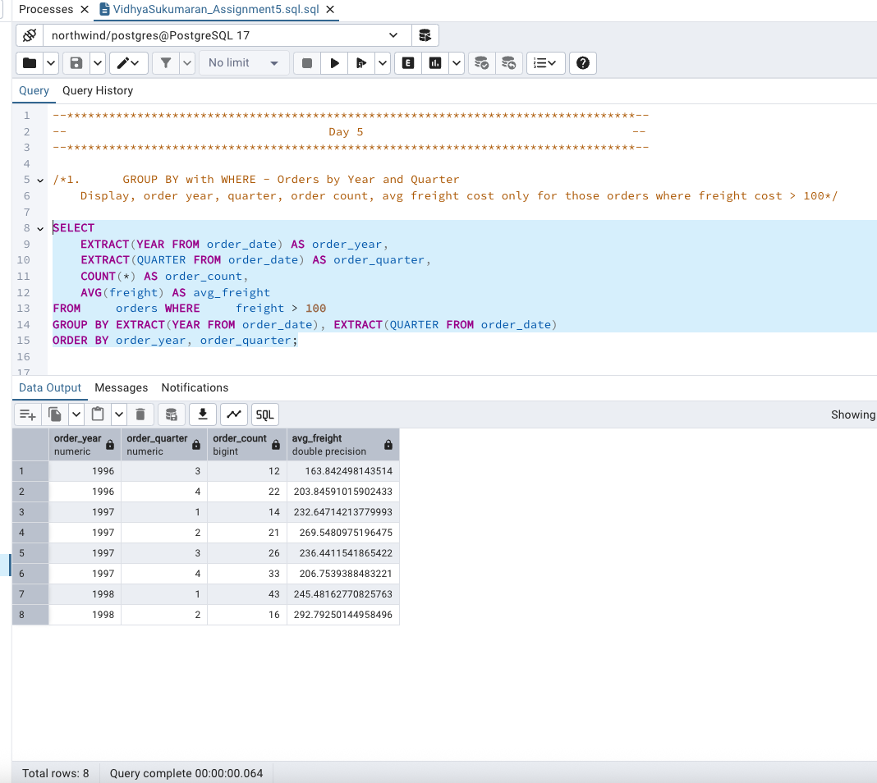

/*2. GROUP BY with HAVING - High Volume Ship Regions

Display, ship region, no of orders in each region, min and max freight cost

Filter regions where no of orders >= 5 */

SELECT

ship_region,

COUNT(*) AS num_orders,

MIN(freight) AS min_freight,

MAX(freight) AS max_freight

FROM orders WHERE ship_region IS NOT NULL

GROUP BY ship_region HAVING COUNT(*) >= 5

ORDER BY num_orders DESC;

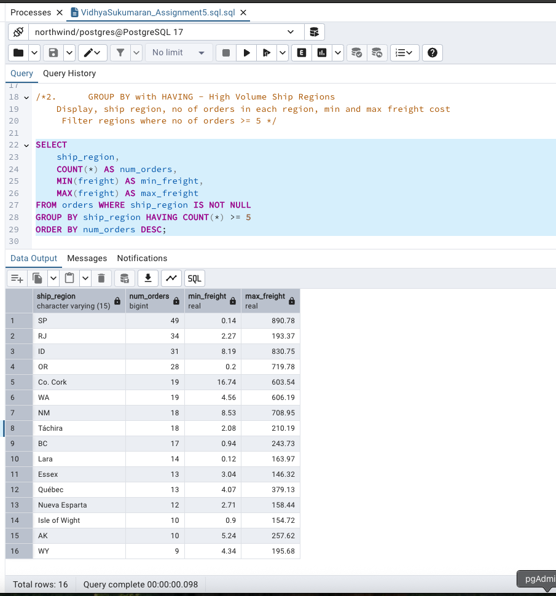

/*3. Get all title designations across employees and customers ( Try UNION & UNION ALL)*/

-- UNION (removes duplicates)

SELECT title AS designation FROM employees

UNION

SELECT contact_title AS designation FROM customers;

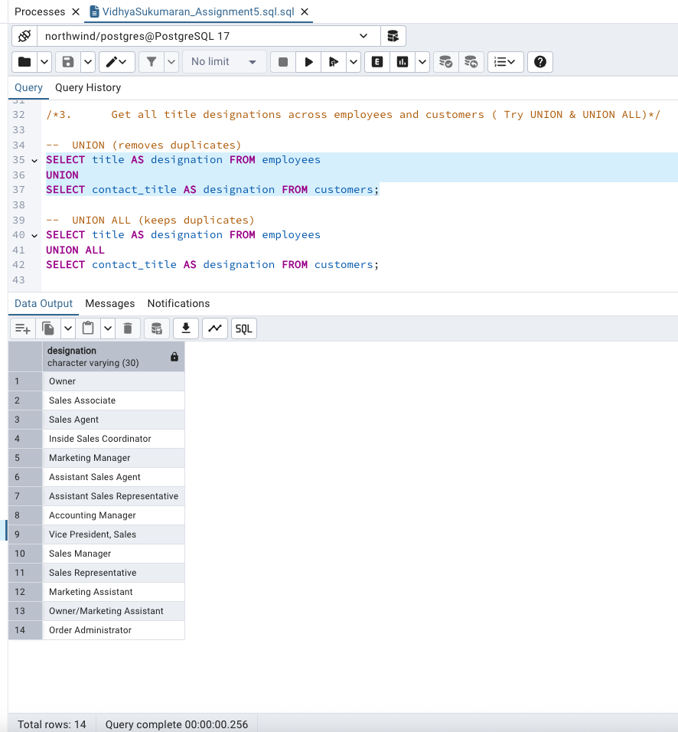

-- UNION ALL (keeps duplicates)

SELECT title AS designation FROM employees

UNION ALL

SELECT contact_title AS designation FROM customers;

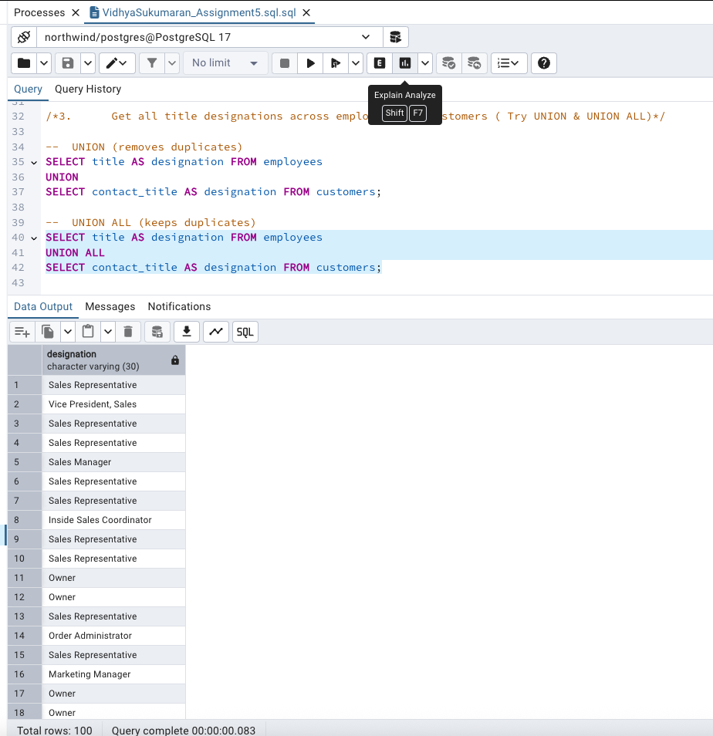

/*4. Find categories that have both discontinued and in-stock products

(Display category_id, instock means units_in_stock > 0, Intersect)*/

SELECT category_id FROM products WHERE discontinued = 1 -- Category IDs that have discontinued products

INTERSECT

SELECT category_id FROM products WHERE units_in_stock > 0; -- Category IDs that have in-stock products

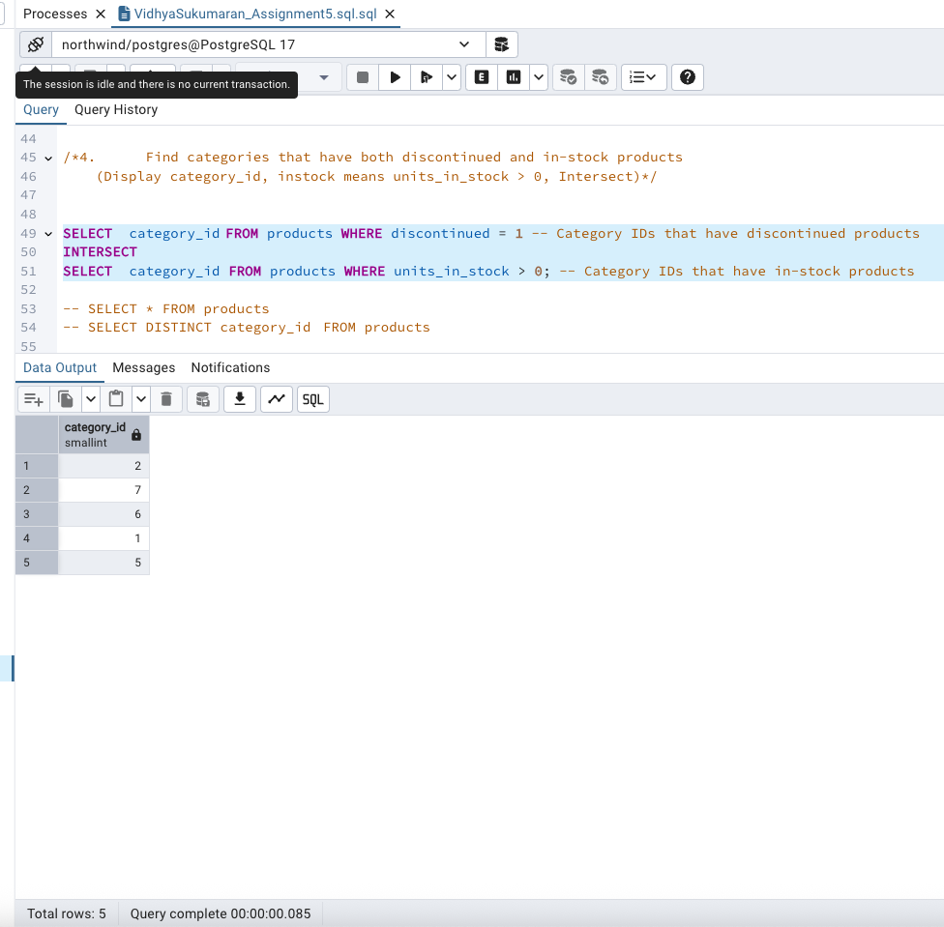

-- SELECT * FROM products

-- SELECT DISTINCT category_id FROM products

/*5. Find orders that have no discounted items (Display the order_id, EXCEPT)*/

SELECT DISTINCT order_id FROM orders -- All orders

EXCEPT

SELECT DISTINCT order_id FROM order_details WHERE discount > 0;-- Orders with any discounted items

